1. 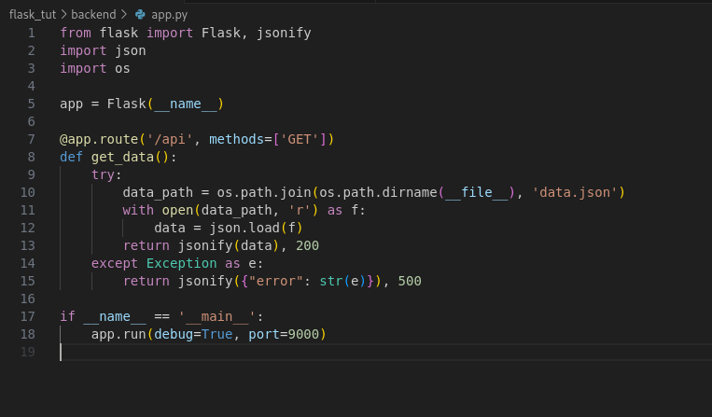**Create a Flask application with an /api route. When this route is accessed, it should return a JSON list. The data should be stored in a backend file, read from it, and sent as a response.**

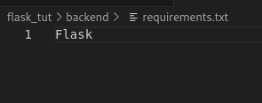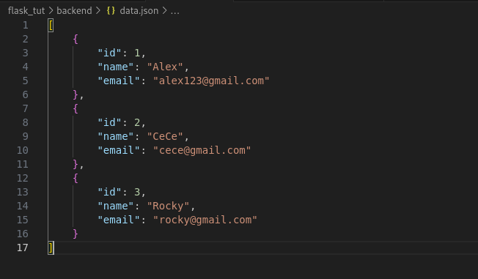

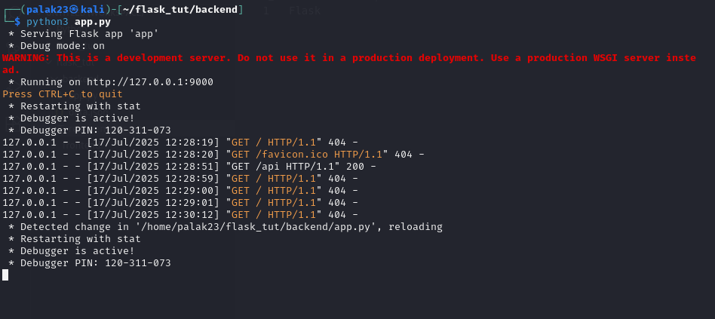

**2. Create a form on the frontend that, when submitted, inserts data into MongoDB Atlas. Upon successful submission, the user should be redirected to another page displaying the message "Data submitted successfully". If there's an error during submission, display the error on the same page without redirection.**

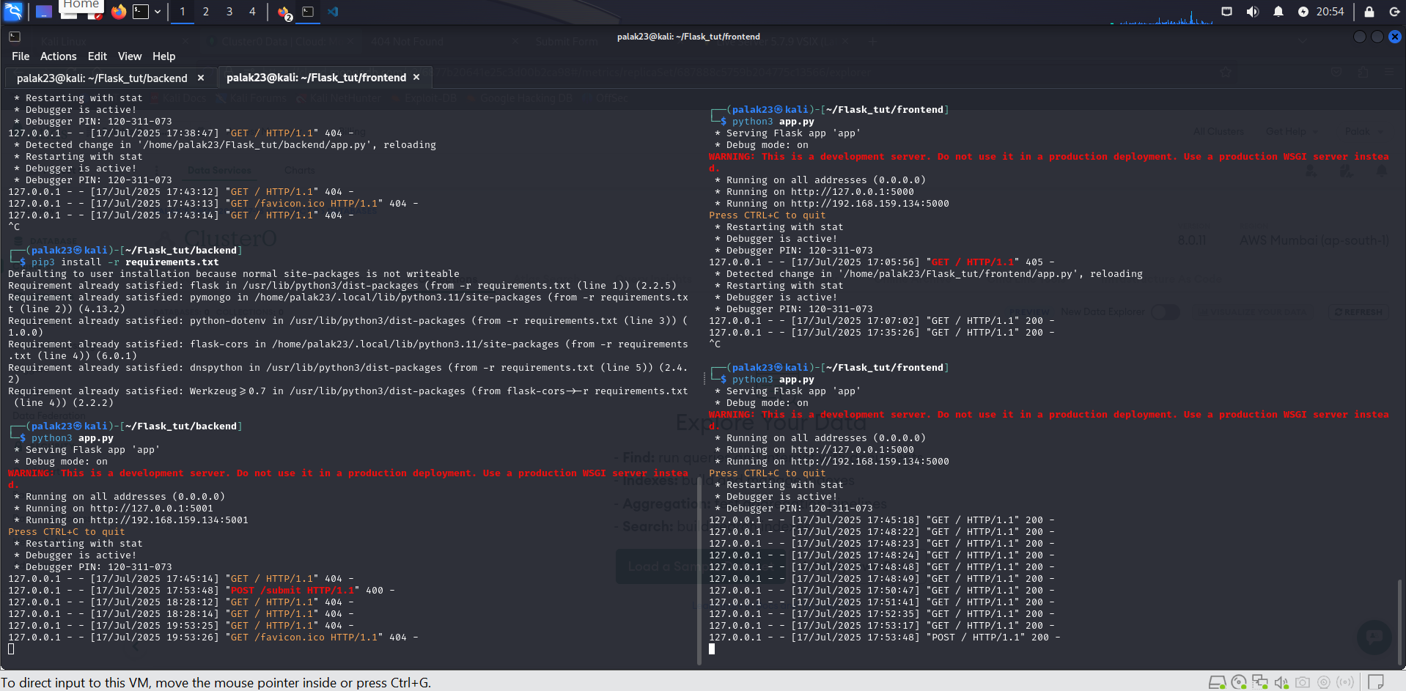

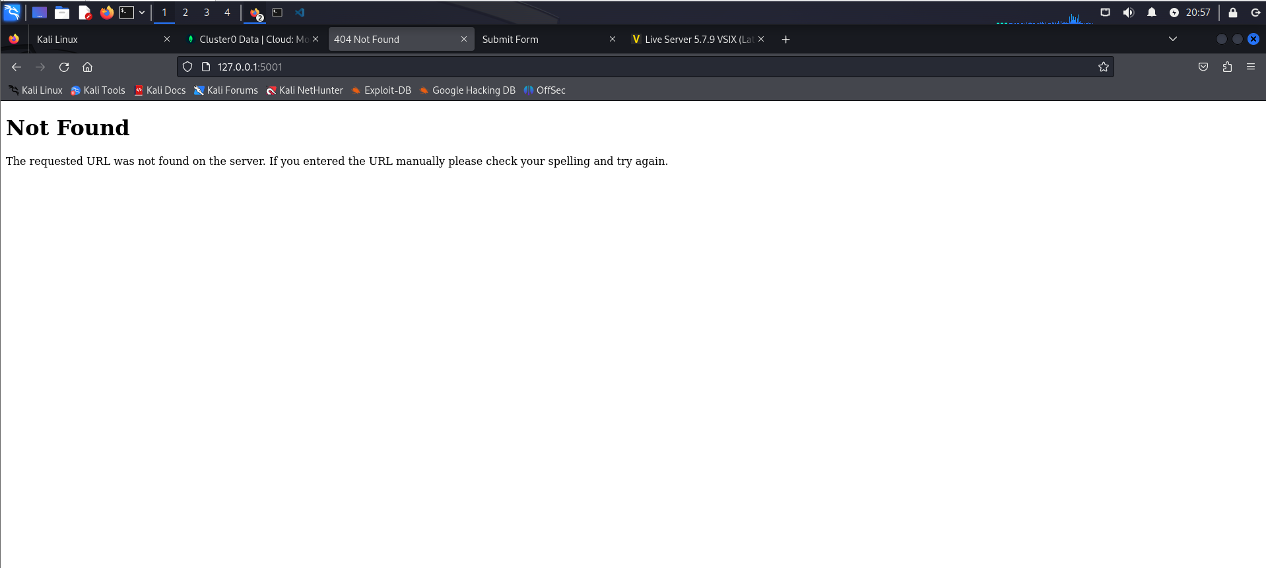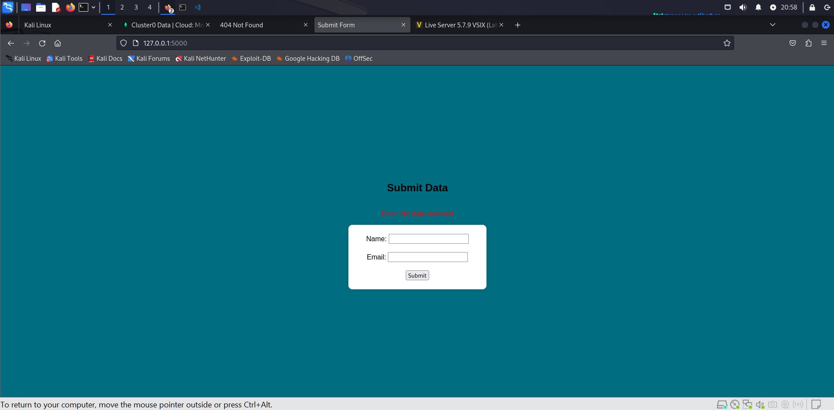

**Code**

**Frontend**

**app.py**

|  |
| --- |
| from flask import Flask, render_template, request, redirect, url_for  import requests  import json  app = Flask(__name__)  BACKEND_URL = "http://localhost:5001/submit"  @app.route("/", methods=["GET","POST"])  def form():  error = None  if request.method == "POST":  form_data = {  "name": request.form["name"],  "email": request.form["email"]  }  try:  response = requests.post(BACKEND_URL, json=form_data)  if response.status_code == 200:  return redirect(url_for("success"))  else:  error = response.json().get("error", "Unknown error occurred")  except Exception as e:  error = str(e)  return render_template("form.html", error=error)  @app.route("/success")  def success():  return render_template("success.html")  if __name__ == "__main__":  app.run(host='0.0.0.0',debug=True, port=5000) |

**requirements.txt**

|  |
| --- |
| flask  requests |

**templates -> form.html**

|  |
| --- |
| <!DOCTYPE html>  <html>  <head>  <title>Submit Form</title>  <style>  body {  background-color: rgb(0, 109, 128);  display: flex;  flex-direction: column;  align-items: center;  justify-content: center;  height: 100vh;  font-family: Arial, sans-serif;  margin: 0;  }  form {  background-color: #ffffff;  border: 1px solid #ccc;  padding: 20px 40px;  border-radius: 10px;  box-shadow: 0 0 10px rgba(0, 0, 0, 0.1);  text-align: center;  }  </style>  </head>  <body>  <h2>Submit Data</h2>  {% if error %}  <p style="color:red;">Error: {{ error }}</p>  {% endif %}  <form method="POST">  Name: <input type="text" name="name" required><br><br>  Email: <input type="email" name="email" required><br><br>  <input type="submit" value="Submit">  </form>  </body>  </html> |

**templates -> success.html**

|  |
| --- |
| <!DOCTYPE html>  <html>  <head>  <title>Success</title>  </head>  <body>  <h2>Data submitted successfully</h2>  </body>  </html> |

**Backend**

**.env**

|  |
| --- |
| MONGO_URI = "mongodb+srv://<username>:<password>@cluster0.workzw3.mongodb.net/test?retryWrites=true&w=majority&appName=Cluster0" |

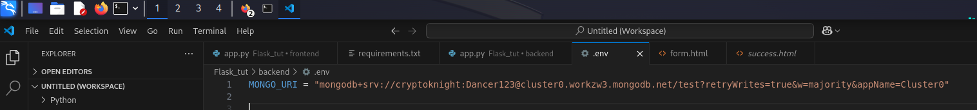**app.py**

|  |
| --- |
| from flask import Flask, request, jsonify  from flask_cors import CORS  from dotenv import load_dotenv  import os  import pymongo  from pymongo.mongo_client import MongoClient  load_dotenv()  app = Flask(__name__)  CORS(app)  # MongoDB connection  MONGO_URI = os.getenv("MONGO_URI")  client = pymongo.MongoClient(MONGO_URI)  db = client.get_database("test")  collection = db["form_data"]  @app.route("/submit", methods=["GET","POST"])  def submit_data():  try:  data = request.form.to_dict()  if not data:  return jsonify({"error": "No data received"}), 400  collection.insert_one(data)  return jsonify({"message": "Data submitted successfully"}), 200  except Exception as e:  return jsonify({"error": str(e)}), 500  if __name__ == "__main__":  app.run(host='0.0.0.0',debug=True, port=5001) |

**requirements.txt**

|  |
| --- |
| flask  pymongo  python-dotenv  flask-cors  dnspython |